
NAME : G.Madhuri Chowdary
CLASS : CSE B
COURSE CODE : 23 CSE111
OBJECT ORIENTED PROGRAMMING SYSTEM
LAB REPORT
Department of Computer Science Engineering

VERIFIED BY:

WEEK- 1
# Explain the process of initializing JDK?
Aim:
Installing of JDK (Java Development Kit)
Download JDK:
Open Chrome browser and search for JDK download now open the first website of Oracle to download JDK click on JDK-21 version to get long term Support (LTS)
Installation of JDK:
Click on the download as per your os (Linux, Macos,windows).
Once the download is completed, run the installer Click on the Next button until the installation is completed.Allow java to make changes in your device.
Setting Environment Variables:
Open file explorer Go to this PC ,now open windows(C) click on program files, next click on java open JDK 21, go to bin and now copy the path address. Then after in search bar, search for environment variables open environment variable go to system variables click on new, paste the copied path.
now click on 'ok' 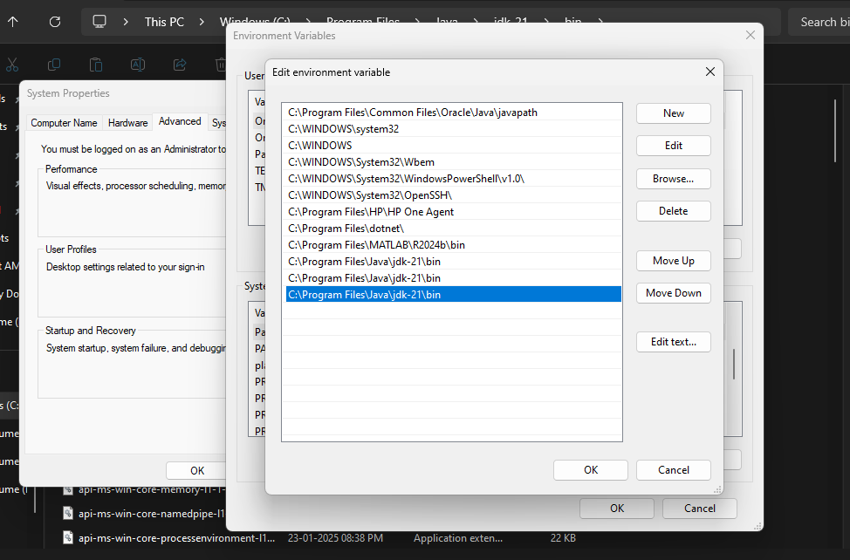

Checking of JDK Version:
Open Command Prompt and press on (Windows+R).
and now type your command and click on Enter button
Check the Version of JDK :
Type java--Version and click Enter
Type javac --Version and click Enter.
Simple java program for printing.
# Name of the Class ,section and roll no of a student Open Notepad and execute command prompt
CODE:
Class Main {
public static void main(String[] args) {
System.out.printIn ("Name: MadhuriChowdary”)
System.out .println("Section: CSE-B”);
System.out. printIn ("Rollno: AV.SC.U4CSE 24106");
}
}
Output:
Name: MadhuriChowdary
Section:CSE-B
RollNo:AV.SC.U4CSE24106

WEEK-2
1. Write a java program to find the simple intrest required values are taken from the user ?
CODE:
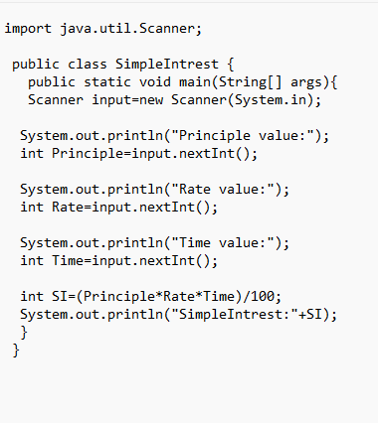
Output:
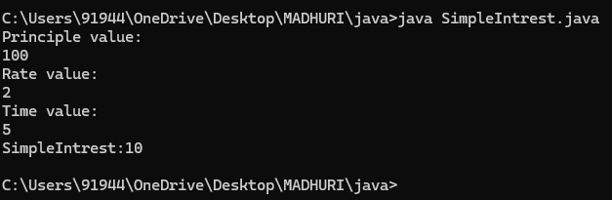

2.Write a Java program to find the factorial of a given number ?
CODE :
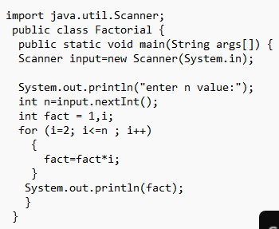
Output :
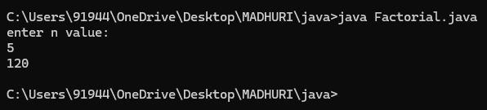
3. Write a java program to print Fibonacci series ?
CODE:
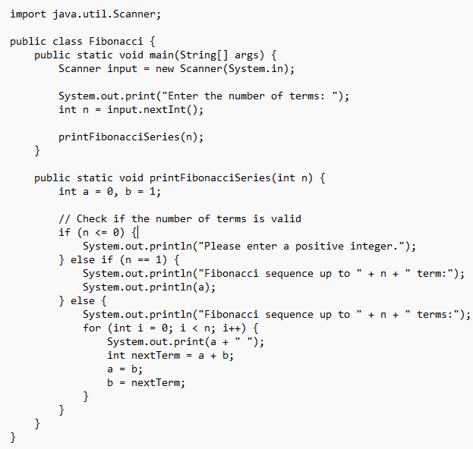
Output:
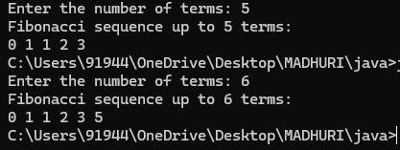
4. Write a java program to print Area of triangle using heron’s formula ?
CODE:
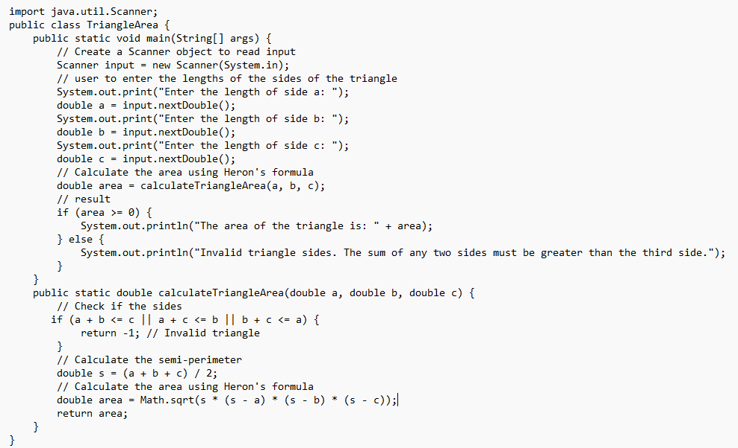
Output:
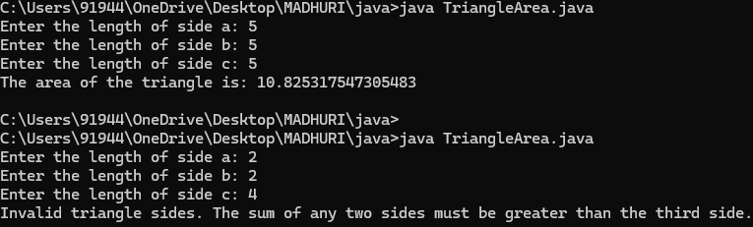
5.Write a java program to convert temperature from Celsius to Fahrenheit and vice versa
CODE:
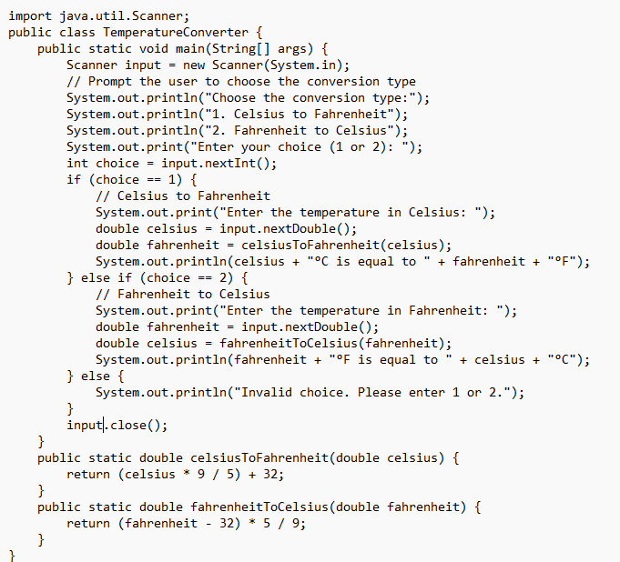

Output:
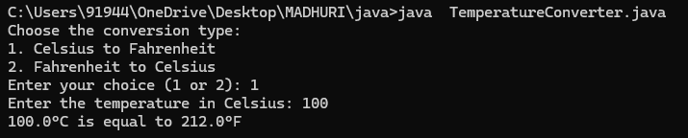
WEEK-3
1.Create a java program to the following instructions?
- Create a class with name car
- Create four attributes names – carcolour,carbrand,fueltype,mileage
- Create three methods named – start ,stop,service
- Create three objects named – c1, c2,c3.
- Create a constructor with parameter - carcolour,carbrand,fueltype,mileage.
CODE:
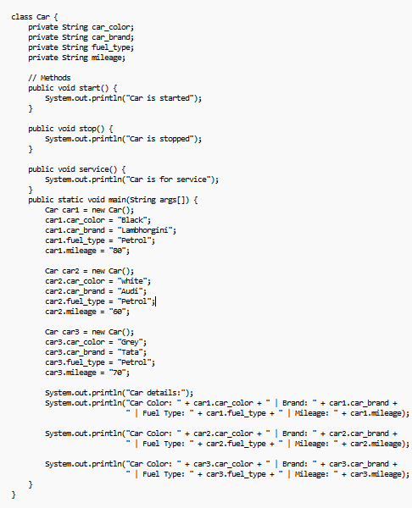

OUTPUT:
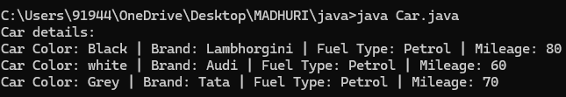
Errors:
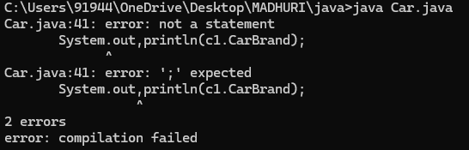
# Rectified by replacing with fullstop (“.”)
Class Daigram:
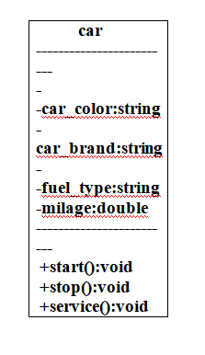
2. Create a class named, bank account with methods -deposit and withdraw, where the deposit method should accepts a parameter and when this method is called the deposit method should be added to current, balance in addition to that when a withdraw method is called it has to verify whether withdraw is lesser than current balance if not display there are insufficient funds
Use the constructor to display the details of the customer (Customer name, acc number, IFC, branch)
Also create two customer objects C1, C2
CODE:
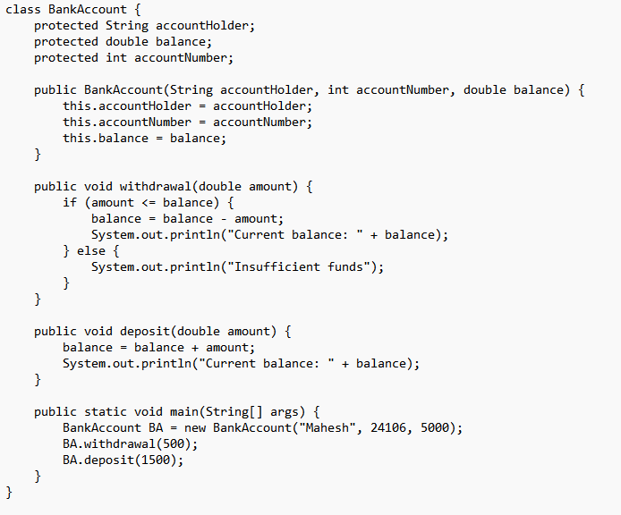
OUTPUT:
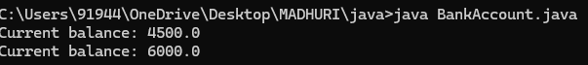
ERRORS
Don’t forgot semi colon .
Class should start with Capital letter .

Class diagram:
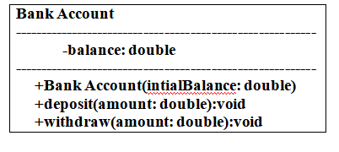

Week-4
- Write a java program with class named book the class should contain various attributes such as title ,author, year of publication .It should also contain a constructor with parameters with initializes title ,author and year of publication create a method which displays the details of the book
(display the details of two book i.e, create two books and objects with details).
CODE :

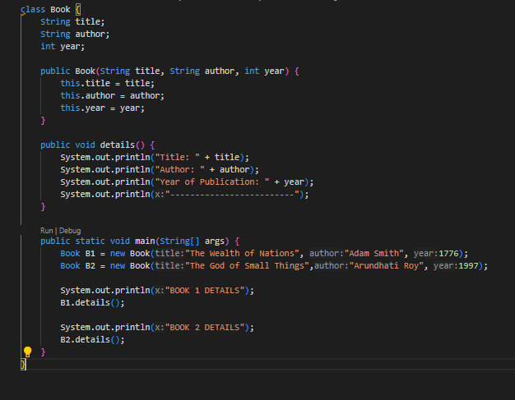
Output :
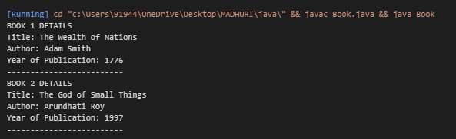
Syntax error :
Forgot to keep “ } ”
Rectification :
“}” is added.
Class diagram:
Book
title : String
author : String
year : int
+ book(title: String, author: String, Year: int)
+ details(): void
- Write a java program to create a class named my class with a static variable count of int type and initialize to zero and a constant variable pie of double data type ,initialize to 3.1415 as attributes of that class now define a constructor for my class that increments the count variables each time an object of my class is created variable each time an object of myclass is created. Finally print the final values of count and pie variables.

CODE :
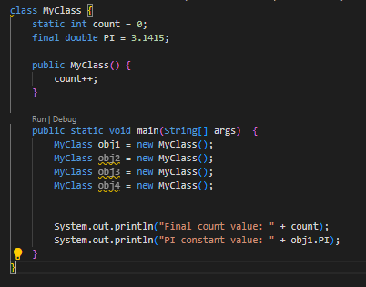

Output :
Error:
String forgot in main function
Rectification:
String is added
Class diagram:
Myclass
Count : int
PIE : double
+Myclass()

WEEK 5
1) Create a calculator using the operations including addition, subtraction, multiplication and division using multilevel in heritance and display the desired output.
- Write your code in VS CODE and execute
- Important Points:
      - Understand the calling of a Constructor
      - Giving class name correctly
      - Give the parameters Correctly
CODE:

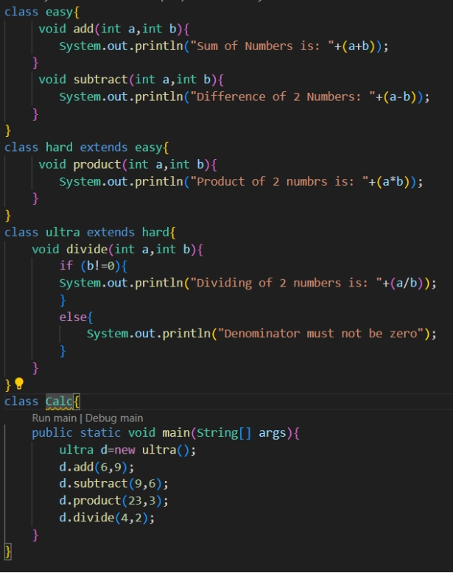
OUTPUT:
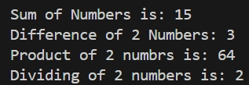
Errors:
S.NO | Error Name | Error Rectification
1 | Syntax/ Compilation Error | Absence of Semicolon
2 | Closing Brackets | Need to Close the brackets
3 | Class Name Error | Give the class name correctly
4 | Constructor Calling | Call the constructor correctly

2) Vehicle rental company wants to develop a system that maintains information about different types of vehicles available for rent. The company rents out cars and bikes and they need a program to store details about each vehicle such as brand and speed.
i. Cars should have an additional property: number of doors, Seating capacity.
ii. Bikes should have a property indicating whether they have gears or not.
iii. The system should also include a function to display details about each vehicle and indicate when a vehicle is starting.
iv. Each class should have a constructor.
Questions:
1. Which OOP concept is used in the above program? Explain why it is useful in this scenario.
2. If the company decides to add a new type of vehicle ‘Truck’, how would you modify the program?
a. Truck should include and additional property capacity (in tons).
b. Create a showTruck() method to display the truck’s capacity.
c. Write a constructor for truck that initializes all properties.
3. Implement the truck class and update the main method to create a Truck object and also create an object for car and bike subclasses. Finally display the details.
- Write your code in VS CODE and execute
- Important Points:
      - Understand the calling of a Constructor
      - Giving class name correctly
      - Give the parameters Correctly
CODE:
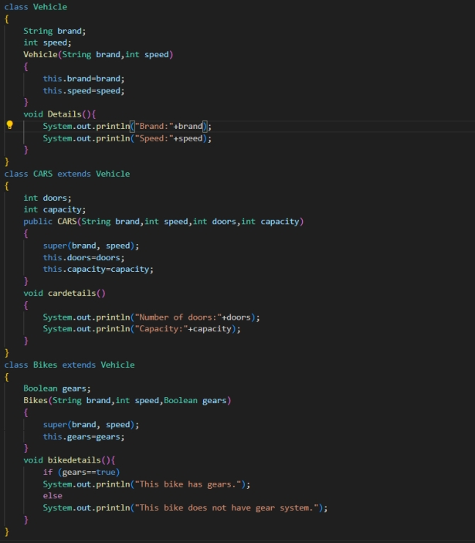

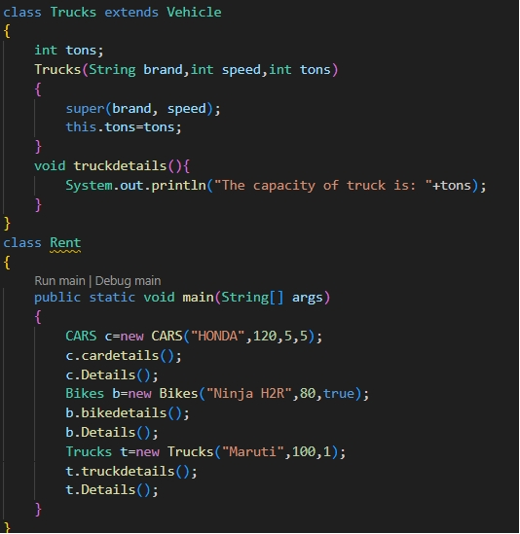
OUTPUT:
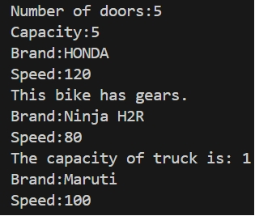

Errors:
S.NO | Error Name | Error Rectification
1 | Syntax/ Compilation Error | Absence of Semicolon
2 | Closing Brackets | Need to Close the brackets
3 | Class Name Error | Give the class name correctly
4 | Constructor Calling | Call the constructor correctly

WEEK-6
1) Write a Java program to create a vehicle class with a method displayInfo(). Override this method in the car subclass to provide specific information about a car, model, fuel type, and color using the constructor

- Write your code in VS CODE and execute
- Important Points:
      - Understand the calling of a Constructor
      - Giving class name correctly
      - Give the parameters Correctly
CODE:
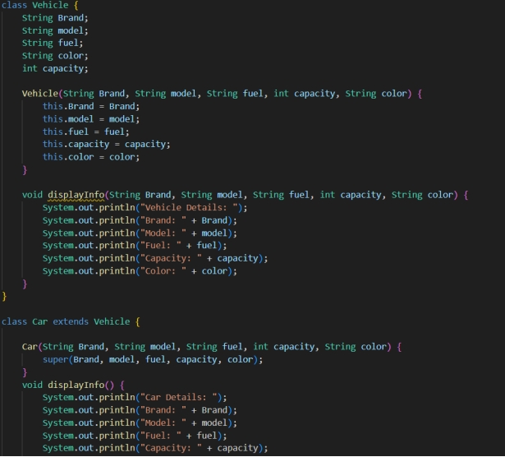
CODE:
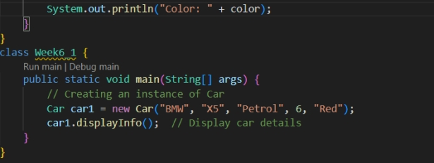

OUTPUT:
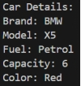
Errors:
S.NO | Error Name | Error Rectification
1 | Syntax/ Compilation Error | Absence of Semicolon
2 | Closing Brackets | Need to Close the brackets
3 | Class Name Error | Give the class name correctly
4 | Constructor Calling | Call the constructor correctly
2) Create a Java program for the scenario.
A college is developing an automated admission system that verifies student eligibility for undergraduate (UG) and postgraduate(PG) programs. Each program has different eligibility criteria based on the student's percentage in their previous qualification.
i) UG admissions require a minimum of 60%
ii) PG admissions require a minimum of 70%

- Write your code in VS CODE and execute
- Important Points:
      - Understand the calling of a Constructor
      - Giving class name correctly
      - Give the parameters Correctly
CODE:
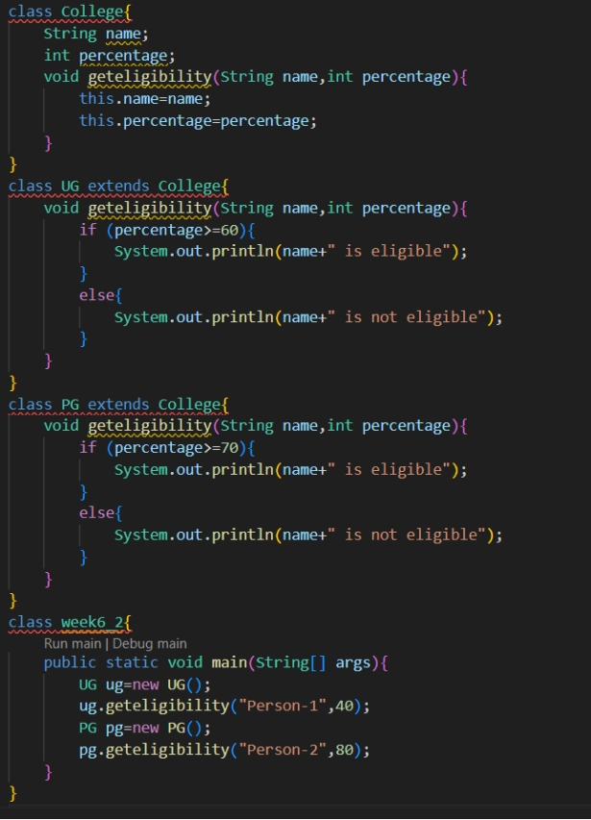
OUTPUT:
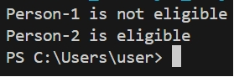

Errors:
S.NO | Error Name | Error Rectification
1 | Syntax/ Compilation Error | Absence of Semicolon
2 | Closing Brackets | Need to Close the brackets
3 | Class Name Error | Give the class name correctly
4 | Constructor Calling | Call the constructor correctly

3) Write a Java Program to create a Calculator class with overloaded methods to perform addition: Take the integer values a and b from the user.
i) Add two integers
ii) Add two doubles
iii) Add three integers
- Write your code in VS CODE and execute
- Important Points:
      - Understand the calling of a Constructor
      - Giving class name correctly
      - Give the parameters Correctly
CODE:
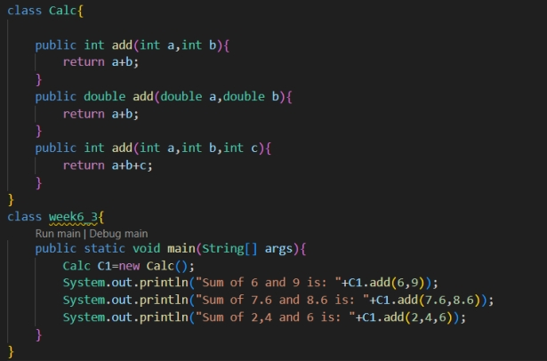

OUTPUT:
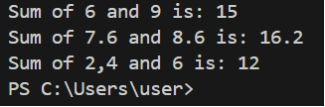

Errors:
S.NO | Error Name | Error Rectification
1 | Syntax/ Compilation Error | Absence of Semicolon
2 | Closing Brackets | Need to Close the brackets
3 | Class Name Error | Give the class name correctly
4 | Constructor Calling | Call the constructor correctly

4) Write a Java Program to create a shape class with a method calculateArea() that is overloaded for different shapes(e.g., Square, Rectangle ). Then create a subclass Circle that overrides the calculateArea() method for a circle.
- Write your code in VS CODE and execute
- Important Points:
      - Understand the calling of a Constructor
      - Giving class name correctly
      - Give the parameters Correctl
CODE:
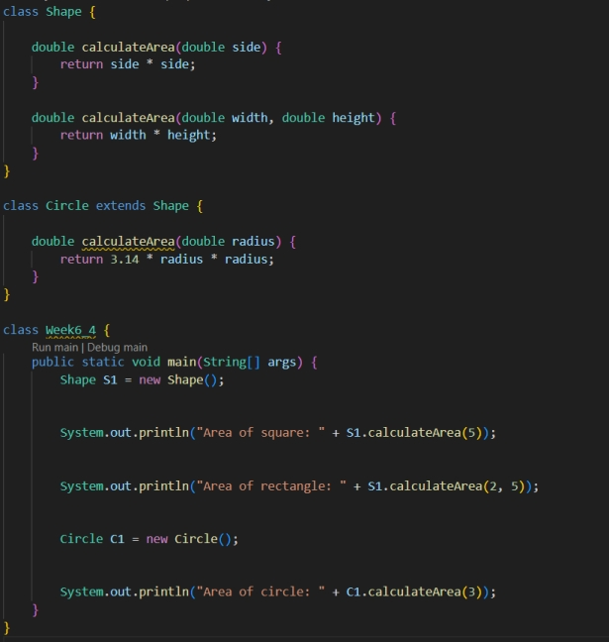
OUTPUT:
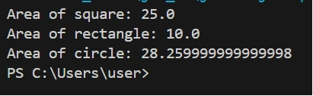

Errors:
S.NO | Error Name | Error Rectification
1 | Syntax/ Compilation Error | Absence of Semicolon
2 | Closing Brackets | Need to Close the brackets
3 | Class Name Error | Give the class name correctly
4 | Constructor Calling | Call the constructor correctly

WEEK-7
1. . Write a java program to create an abstract class Animal with an abstract method called sound().Create subclass Lion and Tiger that extends the Animal class and implement the sound() method to make a specific sound for each Animal
CODE:
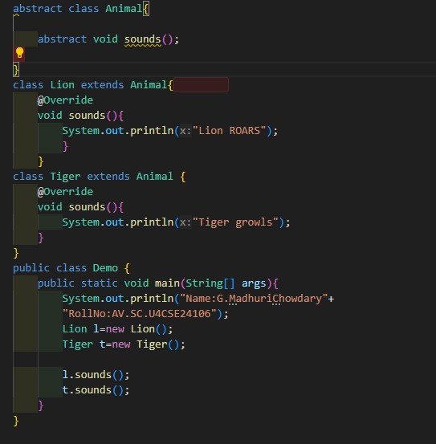
Output:
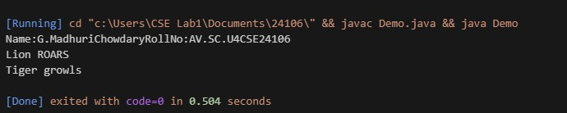

2. Write a Java program to create abstract class Shape 3D with abstract method calculate (Volume and Calculate Surface-Area). Create Subclass sphere and cube that extend the Shape 3D class and implement the respective methods to calculate volume and surface area of each shape.
CODE:
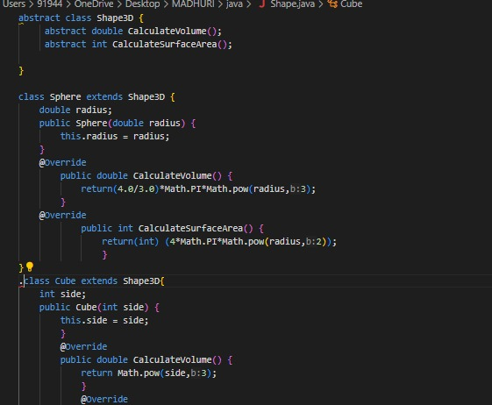
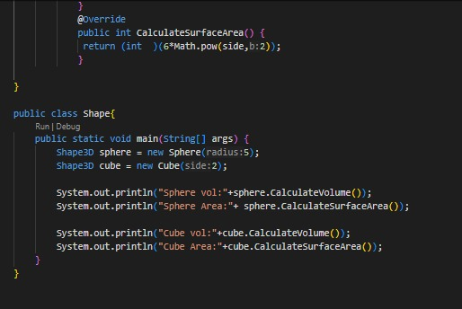
OUTPUT:
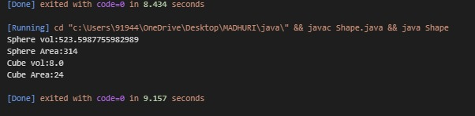
ERRORS
Return type mismatch in Sphere and Cube:
Calculate SurfaceArea() is supposed to return int, but here it is trying to return a double.
Incorrect System.out.println() syntax:
typos: ptintln, extra semicolons, and misplaced parentheses.
3.write a java program using abstract class to define a method of pattern printing create an abstract class named pattern printer with an abstract method print pattern(int n) and concrete method to display the pattern title Implement two subclass star pattern printing in increasing right angle triangle number in ascending order of right angle triangle in main() method create objects of both subclass and print the patterns for a given number of rows explain every line code
CODE :
abstract class PatternPrinter {
abstract void printPattern(int n);

void displayTitle(String title) {
System.out.println("Pattern: " + title);
}
}

class StarPattern extends PatternPrinter {
@Override
void printPattern(int n) {
displayTitle("Star Pattern");

for (int i = 1; i <= n; i++) {
for (int j = 1; j <= i; j++) {
System.out.print("* ");
}
System.out.println();
}
}
}

class NumberPattern extends PatternPrinter {
@Override
void printPattern(int n) {
displayTitle("Number Pattern");

int num = 1;
for (int i = 1; i <= n; i++) {
for (int j = 1; j <= i; j++) {
System.out.print(num + " ");
num++;
}
System.out.println();
}
}
}

public class PatternDemo {
public static void main(String[] args) {
int rows = 5;

PatternPrinter star = new StarPattern();
PatternPrinter number = new NumberPattern();

star.printPattern(rows);
System.out.println();
number.printPattern(rows);
}
}

OUTPUT:
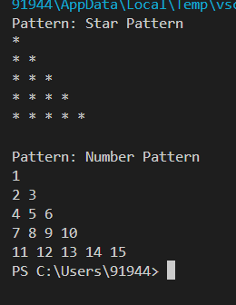
WEEK – 8

1.Write a java program to create an interface shape with the get perimeter() method.Create three classes Rectangle,Circle and Triangle that implements the shape interface.Implement get perimeter() method for each of three classes.
Code:

interface Shape {
double getPerimeter();
}

class Rectangle implements Shape {
double length;
double width;

Rectangle(double length, double width) {
this.length = length;
this.width = width;
}

public double getPerimeter() {
return 2 * (length + width);
}
}

class Circle implements Shape {
double radius;

Circle(double radius) {
this.radius = radius;
}

public double getPerimeter() {
return 2 * Math.PI * radius;
}
}

class Triangle implements Shape {
double sideA, sideB, sideC;

Triangle(double sideA, double sideB, double sideC) {
this.sideA = sideA;
this.sideB = sideB;
this.sideC = sideC;
}

public double getPerimeter() {
return sideA + sideB + sideC;
}
}

public class Main8a {
public static void main(String[] args) {
Shape rect = new Rectangle(5, 3);
Shape circ = new Circle(4);
Shape tri = new Triangle(3, 4, 5);

System.out.println("Rectangle Perimeter: " + rect.getPerimeter());
System.out.println("Circle Perimeter: " + circ.getPerimeter());
System.out.println("Triangle Perimeter: " + tri.getPerimeter());
}
}

OUTPUT :
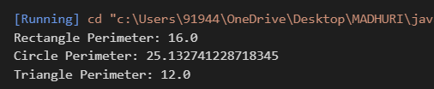
IMPORTANT POINTS :
Method Overriding:
- All classes override getPerimeter() with their own logic..
Polymorphism in Main Class:
- Shape references are used for all objects (Rectangle, Circle, Triangle).
- Demonstrates dynamic method dispatch.
Use of Math.PI:
- Ensures precision in circle perimeter calculation.

CLASS DAIGRAM :
+---------------- +
| <<interface>> |
| Shape |
+ ---------------- +
| +getPerimeter() |
+---------------- +
▲
┌───────────┼───────────┐
│ │ │
+------------+ +----------+ +-------------+
| Rectangle | | Circle | | Triangle|
+------------+ +----------+ +-------------+
| - length | | - radius | | - sideA |
| - width | +----------+ | - sideB |
+------------+ | - sideC |
| +getPerimeter()| +-------------+
+------------+ | +getPerimeter()|
+ ------------- +

2.Write a java program to an interface playable with a method play that takes no args and returns void .Create three classes Football,Volleyball,Basketball that implements playable interface and override the play() method to play the respective sports.

CODE:

interface Playable {
void play();
}
class Football implements Playable {
public void play() {
System.out.println("Name:G.MadhuriChowdary ROLLNO:AV.SC.U4CSE24106");
System.out.println("Playing Football...");
}
}
class Volleyball implements Playable {
public void play() {
System.out.println("Playing Volleyball...");
}
}
class Basketball implements Playable {
public void play() {
System.out.println("Playing Basketball...");
}
}

public class Main8b {
public static void main(String[] args) {
Playable f = new Football();
Playable v = new Volleyball();
Playable b = new Basketball();

f.play();
v.play();
b.play();
}
}

OUTPUT:
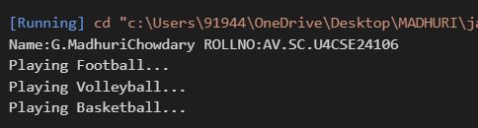

ERRORS:

Syntax Error | Misplaced brackets or incorrect method/class declarations.

Or If forget semicolons after statements.

Compilation Error | If System.out.println() is misspelled (e.g., Systm or Sytem).

Important Points (Short Version)
- Playable is an interface with void play() method.
- Football, Volleyball, and Basketball implement Playable.
- Each class overrides play() with its own message.
- Demonstrates method overriding and polymorphism.
- System.out.println() is used inside play() to print actions.

